* Write a program to input a tuple and create a two new tuple from it, one containing its every 3rd element in reverse order, starting from the last element another containing every alternate element lying between 3rd to 9th element.

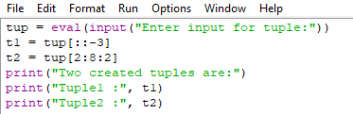

* Result-

